Screenshots or program listings must be copied into appropriate cells in the following table.
Save this evidence document as evidence_ followed by your centre number_ candidate number, for example, evidence_ zz999_9999 and insert your name, centre number and candidate number into the header above.
Examiners must be able to read the contents including any screenshots without the use of a magnifying glass. Answers that are not readable or are missing will not be awarded any marks.
Save this evidence document at regular intervals, for example every 10 minutes.
Question 1
Part 1(a)
BeverageQueue = [None for _ in range(10)] # OF STRING
BeverageFrontPointer = 0 # INTEGER
BeverageRearPointer = 0 # INTEGER

Part 1(b)(i)
def DisplayMenu():
try:
file = open("BeverageData.txt", 'r')
beverage = file.readline().strip()
while beverage != "":
print(beverage)
beverage = file.readline().strip()
except FileNotFoundError:
print("File not found")
file.close()

Part 1(b)(ii)
def TakeOrder():
menu_array = [] # OF STRING
try:
file = open("BeverageData.txt", 'r')
beverage = file.readline().strip().lower()
while beverage != "":
menu_array.append(beverage)
beverage = file.readline().strip().lower()
except FileNotFoundError:
print("File not found")
file.close()

try:
file = open("Order.txt", 'w')

customer_order = input() # STRING
order_array = customer_order.split(',') # OF STRING

for order in order_array:
order = order.strip()
if order.lower() in menu_array:
file.write(order + "\n")

except FileExistsError:
print("File already exists")
file.close()

Part 1(b)(iii)
def EnqueueBeverage(DataToEnqueue):
global BeverageRearPointer
if BeverageRearPointer == 10:
return False
else:
BeverageQueue[BeverageRearPointer] = DataToEnqueue
BeverageRearPointer = BeverageRearPointer + 1
return True

Part 1(b)(iv)
def ReadOrderData():
try:
file = open("Order.txt", 'r')
next_line = file.readline().strip() # STRING
while next_line != "":
EnqueueBeverage(next_line)
next_line = file.readline().strip()

except FileNotFoundError:
print("File not found")

Part 1(c)(i)
def DequeueBeverage():
global BeverageFrontPointer
if BeverageFrontPointer == BeverageRearPointer:
return ""
else:
ReturnData = BeverageQueue[BeverageFrontPointer] # STRING
BeverageFrontPointer = BeverageFrontPointer + 1
return ReturnData

Part 1(c)(ii)
def ServeItem():
beverage = DequeueBeverage() # STRING
if beverage == "":
print("No more orders to serve")
else:
print("You ordered", beverage)

Part 1(d)(i)
DisplayMenu()
TakeOrder()
ReadOrderData()
for i in range(BeverageRearPointer - BeverageFrontPointer):
ServeItem()

Part 1(d)(ii)
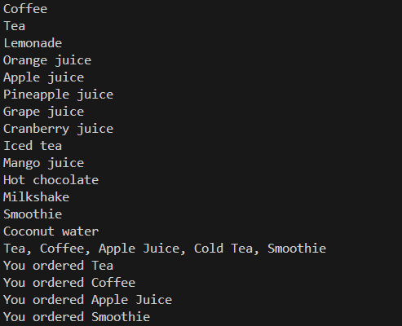

Question 2
Part 2(a)
Data = [[None for _ in range(4)] for __ in range(5)]
Rows = 5

Part 2(b)
def SetUp():
global Rows
try:
row_num = -1
while row_num < 1 or row_num > 5:
row_num = int(input("No. of rows: "))

Rows = row_num
for i in range(row_num):
for j in range(4):
Data[i][j] = int(input("Enter data: "))

except ValueError:
print("Invalid Number")

Part 2(c)(i)
SetUp()
for row in Data:
print(row)

Part 2(c)(ii)
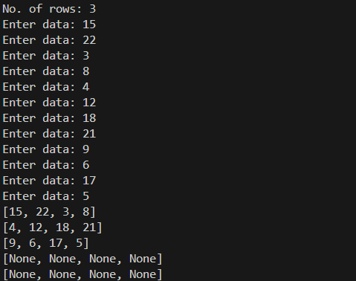

Part 2(d)(i)
def BubbleSort():
for k in range(Rows):
row = Data[k] # OF INTEGER
for i in range(4):
for j in range(3):
if row[j] > row[j + 1]:
temp = row[j] # INTEGER
row[j] = row[j + 1]
row[j + 1] = temp

Part 2(d)(ii)
BubbleSort()
for row in Data:
print(row)

Part 2(d)(iii)
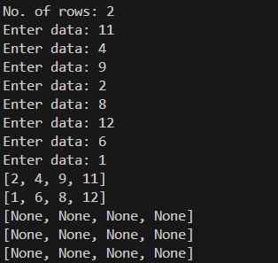

Part 2(e)(i)
def RecursiveBinarySearch(row_num, DataToFind, low, high):
if low > high: return -1

mid = (low + high) // 2 # INTEGER
if Data[row_num][mid] == DataToFind: return mid
if Data[row_num][mid] > DataToFind: return RecursiveBinarySearch(row_num, DataToFind, low, mid - 1)
if Data[row_num][mid] < DataToFind: return RecursiveBinarySearch(row_num, DataToFind, mid + 1, high)

Part 2(e)(ii)
try:
search_row_num = int(input("Enter a row to search: ")) # INTEGER
data_to_find = int(input("Enter a data to find: ")) # INTEGER

result = RecursiveBinarySearch(search_row_num - 1, data_to_find, 0, 3) # INTEGER
if result == -1: print("Number not found.")
else: print(f"Number found at column {result + 1} in row {search_row_num}")

except ValueError:
print("Invalid Number")

Part 2(e)(iii)
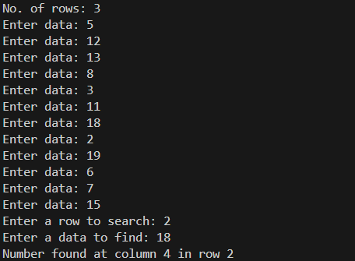

Part 2(e)(iv)
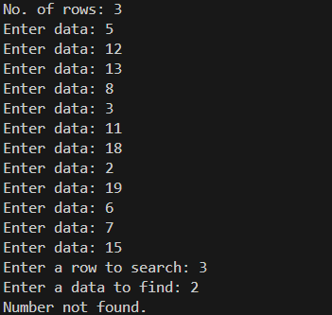

Question 3
Part 3(a)(i)
class Device:
def __init__(self, device_name, brand, battery_life, price):
self.__device_name = device_name # STRING
self.__brand = brand # STRING
self.__battery_life = battery_life # INTEGER
self.__price = price # FLOAT

def get_device_name(self):
return self.__device_name

def get_brand(self):
return self.__brand

def get_battery_life(self):
return self.__battery_life

def get_price(self):
return self.__price

def print_details(self):
print(f"Name: {self.__device_name}, Brand: {self.__brand}, Battery Life: {self.__battery_life}, Price: {self.__price}")

Part 3(a)(ii)
class Phone(Device):
def __init__(self, device_name, brand, battery_life, price, storage):
super().__init__(device_name, brand, battery_life, price)
self.__storage = storage # INTEGER

def get_storage(self):
return self.__storage

def print_details(self):
print(f"Name: {self.get_device_name()}, Brand: {self.get_brand()}, Battery Life: {self.get_battery_life()}, Price: {self.get_price()}, Storage: {self.get_storage()}")}

Part 3(a)(iii)
class Laptop(Device):
def __init__(self, device_name, brand, battery_life, price, ram):
super().__init__(device_name, brand, battery_life, price)
self.__ram = ram # INTEGER

def get_ram(self):
return self.__ram

def print_details(self):
print(f"Name: {self.get_device_name()}, Brand: {self.get_brand()}, Battery Life: {self.get_battery_life()}, Price: {self.get_price()}, Ram: {self.get_ram()}")

class Tablet(Device):
def __init__(self, device_name, brand, battery_life, price, screen_size):
super().__init__(device_name, brand, battery_life, price)
self.__screen_size = screen_size # FLOAT

def get_screen_size(self):
return self.__screen_size

def print_details(self):
print(f"Name: {self.get_device_name()}, Brand: {self.get_brand()}, Battery Life: {self.get_battery_life()}, Price: {self.get_price()}, Screen Size: {self.get_screen_size()}")

Part 3(b)
def ReadDeviceData():
device_array = [] # OF Device

try:
file = open("Devices.txt", 'r')

device_line = file.readline().strip() # STRING

while device_line != "":
device_info = device_line.split(",") # OF STRING

if device_info[0] == "Phone":
device_array.append(Phone(device_info[1], device_info[2], int(device_info[3]), float(device_info[4]), int(device_info[5])))
elif device_info[0] == "Laptop":
device_array.append(Laptop(device_info[1], device_info[2], int(device_info[3]), float(device_info[4]), int(device_info[5])))
else:
device_array.append(Tablet(device_info[1], device_info[2], int(device_info[3]), float(device_info[4]), float(device_info[5])))

device_line = file.readline().strip()

except FileNotFoundError:
print("File not found")

return device_array

Part 3(c)
def PrintDevices(device_array):
for device in device_array:
device.print_details()

Part 3(d)(i)
device_array = ReadDeviceData() # OF Device
PrintDevices(device_array)

Part 3(d)(ii)
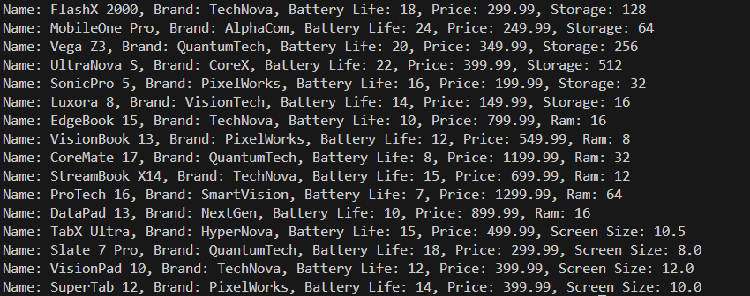

Part 3(e)(i)
def ChooseDevice(device_array):
try:
budget = float(input("Enter a budget: ")) # FLOAT
brand = input("Enter a preffered brand: ") # STRING
battery = int(input("Enter a minimum battery life: ")) # INTEGER
except ValueError:
print("Invalid Number")

matching_array = [] # OF Device

for device in device_array:
if device.get_price() > budget: continue
if device.get_brand() != brand: continue
if device.get_battery_life() < battery: continue

matching_array.append(device)

return matching_array

Part 3(e)(ii)
choice_array = ChooseDevice(device_array) # OF Device
if len(choice_array) == 0: print("No available devices")
else: PrintDevices(choice_array)

Part 3(e)(iii)
